Comprehension

Ex.1.

False: 1, 2, 4, 5, 7, 8, 10

True: 3, 6, 9

Ex.1.

IP – internet protocol;

DSL – digital subscriber line;

ISP – internet service provider

AOL – America Online

Ex.2.

1. F
2. J
3. H
4. B
5. A
6. C
7. I
8. D
9. E
10. G

Ex.4.

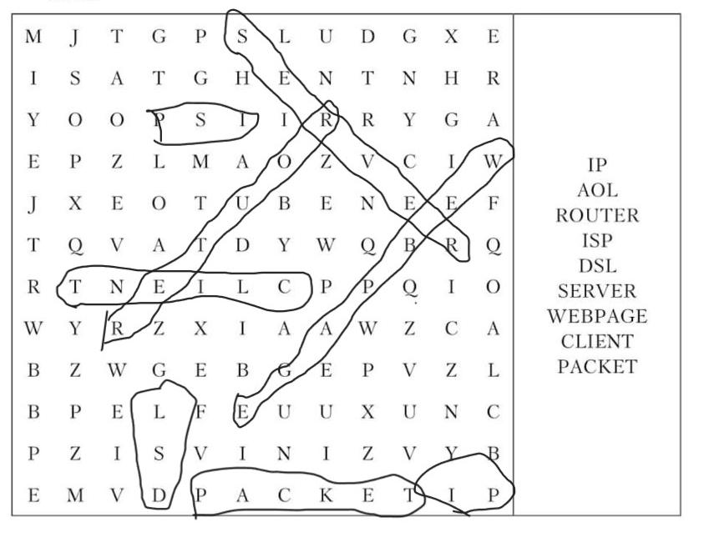

Ex.5.

1. IP addresses
2. Server
3. Clients, internet service provider
4. Coincidentally
5. DSL
6. AOL
7. Webpage
8. Packets, packets
9. routers